**How to Configure Database Mirroring for SQL Server**

Database mirroring provides database availability by mirroring the transaction streams from the principal server to a mirror server.

Database mirroring supports two operating modes:

Synchronous – a transaction must be committed on both principal and mirror server, and/or witness server before considered as completed. This is a real-time protection for a database.

With automatic failover – requires a witness partner.

Without automatic failover – no witness partner.

Asynchronous – a transaction commits without waiting for the mirror partner to write the log to disk.

To configure database mirroring, you can use the following procedure:

1. Connect to the primary server.

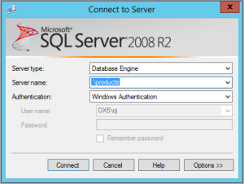

1. Ensure the database is at Full recovery model.

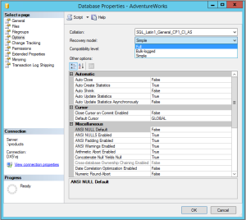

1. Enable database mirroring.

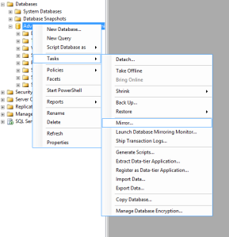

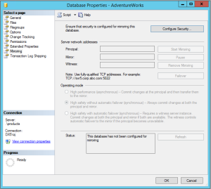

1. Configure database mirroring security.

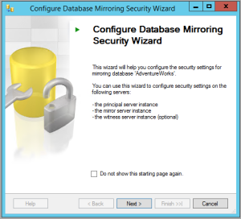

1. Define whether or not a witness server is used for automatic failover. Since we do not want automatic failover, select “No” and continue to next step

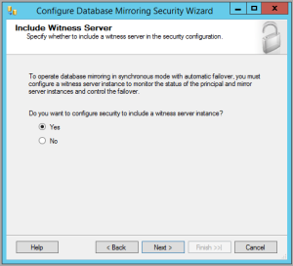

1. Define database mirroring endpoint for the principal server. Be sure to open the listener port in the server firewall.

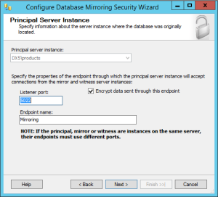

1. Connect and define the endpoint for the mirror server. In order to successfully connect to the secondary server, we must ensure the instance listening port and SQLBrowser listening port are open.

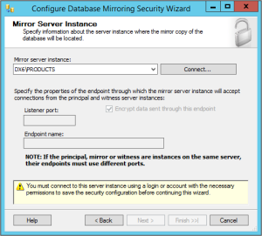

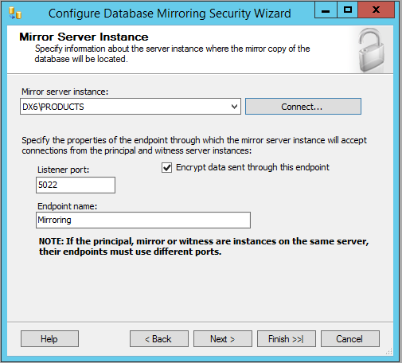

1. Define the security account for principal and mirror server. This service account should be part of the sysadmin SQL server role if it’s not already granted so.

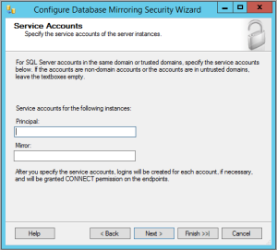

1. Click Finish to commit the endpoint configuration.

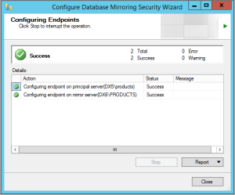

1. Start mirroring session. You would only do so if a full database backup and a transaction log backup from the principal server have been restored on the mirror server with “no recovery”.

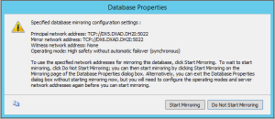

1. If all is configured correctly, the database mirroring session is now active.

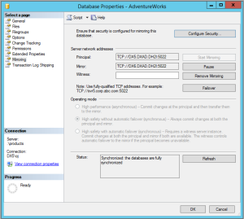

**Ref:**

1. <https://www.youtube.com/watch?v=DlukbLQCkZ0>
2. <https://www.c-sharpcorner.com/UploadFile/nipuntomar/sql-server-database-mirroring-part-1/>
3. <https://www.sqlshack.com/sql-server-database-mirroring/>
4. <https://www.tatvasoft.com/blog/how-to-configure-database-mirroring-for-sql-server/>
5. [https://www.sqlserverlogexplorer.com/database-mirroring-in-sql-server/#](https://www.sqlserverlogexplorer.com/database-mirroring-in-sql-server/)
6. <http://sql-articles.com/articles/high-availability/advantages-a-disadvantages-of-database-mirroring/>
7. [https://www.sqlserverlogexplorer.com/database-mirroring-in-sql-server/#](https://www.sqlserverlogexplorer.com/database-mirroring-in-sql-server/)
8. <http://sqlanddotnetdevelopment.blogspot.com/2012/02/advantage-and-disadvantage-of-database.html>
9. <https://docs.microsoft.com/en-us/sql/database-engine/database-mirroring/database-mirroring-sql-server?view=sql-server-ver15>
10. <https://www.mssqltips.com/sqlservertip/6953/configure-database-mirroring-t-sql-code/>
11. <https://www.youtube.com/watch?v=C_npQPAI1Yo>
12. <https://www.youtube.com/watch?v=M0sQay6qwJ4>
13. <https://www.mssqltips.com/sqlservertip/2464/configure-sql-server-database-mirroring-using-ssms/>
14. <https://www.sqlservercentral.com/blogs/configure-sql-server-database-mirroring-step-by-step>
15. <https://dh2i.com/blog/how-to-configure-database-mirroring-for-sql-server-2/>